**HOME PAGE**

TABS: Home, About Us – RDR Team – Donna’s Story, Speaking – Testimonials, Skydive, PIIMP, RDR Blog, Media-Video Blog, Photos, Media, Sponsors, RDR Shop – Rock Tape, Contact

***The story of an 8 year old girl who survived a stroke, and one woman's journey to learn to run again***

## From 30 steps to a marathon in 11 months!

***(Video)* THE VIDEO THAT STARTED IT ALL IN NOVEMBER 2012!**

See Donna's video blogs of her journey[**here**](http://www.rundonnarun.com.au/#!video-blog/c1q8)

#### ****Donna Runs For The Kids with the PIIMP Team****

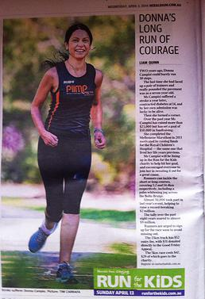

[**See more here**](http://www.rundonnarun.com.au/#!piimp-team/c22uy)

http://static.wixstatic.com/media/946278_308c7c9424064ead9e2b45aa86d835a5.jpg_srz_p_334_63_75_22_0.50_1.20_0.00_jpg_srz

###### Interested in having Donna speak at your next team meeting or event?

Have Donna share her incredible life long journey from surviving a stroke to running in the Melbourne Marathon,

and beyond! Contact her today! [**Click here for more info**](http://www.rundonnarun.com.au/#!speaking/cw04)

[[](http://www.rundonnarun.com.au/#!contact/cvrh)](http://www.rundonnarun.com.au/" \l "!contact/cvrh" \t "_self)

[[http://static.wixstatic.com/media/946278_5217ad726c494df18ec08c0097c2bced.jpg_srz_p_182_53_75_22_0.50_1.20_0.00_jpg_srz](http://www.facebook.com/RunDonnaRun)](http://www.facebook.com/RunDonnaRun" \t "_blank)





**[Click Here for More Info](http://www.rundonnarun.com.au/" \l "!falling-for-a-cause/cydj" \t "_self)**

## Be one of the awesome

## 20 people to join the team

[[](http://www.rchfoundation.org.au/)](http://www.rchfoundation.org.au/" \t "_blank)



## Follow Donna's weekly

## blog

## [here](http://www.rundonnarun.com.au/#!rdr-blog/ccby)

## AS SEEN IN...

http://static.wixstatic.com/media/946278_308c7c9424064ead9e2b45aa86d835a5.jpg_srz_p_239_43_75_22_0.50_1.20_0.00_jpg_srz





http://static.wixstatic.com/media/946278_b7d8ca9ba3e0b26421a28819729bd2aa.gif_srz_p_159_60_75_22_0.50_1.20_0.00_gif_srz

http://static.wixstatic.com/media/946278_326ed48205b1d0a65362e1958d08569b.jpg_srz_p_199_27_75_22_0.50_1.20_0.00_jpg_srz





## Enter for your chance to win an

## awesome

## pair of Vapor

## runners!

## It's easy!

## Enter your details above

## Entries close

## October 1

## 

## 

**RDR Competition!**



Enter here!

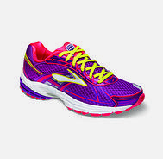

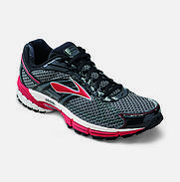

http://static.wixstatic.com/media/946278_a94d15fcc2b64fefafe1966c1ac93221.gif_srz_p_265_34_75_22_0.50_1.20_0.00_gif_srz

**Funds raised by RunDonnaRun will go towards the Royal Children's hospitals  ‘Wish List’. Wish list funds are incredibly important because they support the hospital’s ability to respond swiftly and flexibly to the most immediate and pressing needs at any time, across all departments.**

**By supporting Donna, you are directly helping our world-leading hospital continue to provide the best care for our most vulnerable children and their families.**

[[](https://rundonnarun.everydayhero.com/au/piimp-my-run/members)](https://rundonnarun.everydayhero.com/au/piimp-my-run/members" \t "_blank)

(Slide show)

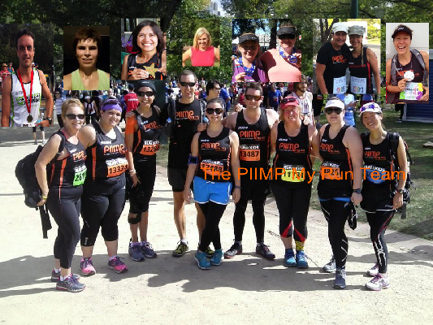

The PIIMP My Run Team



Check out Donna's blog

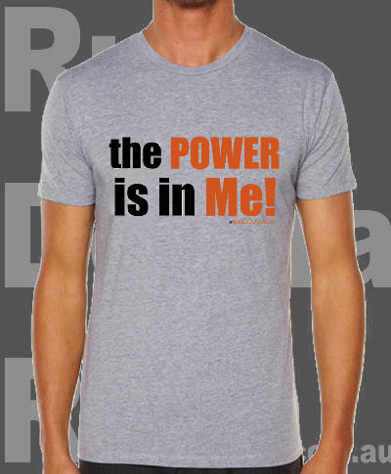

Get your Tee at the RDR Shop

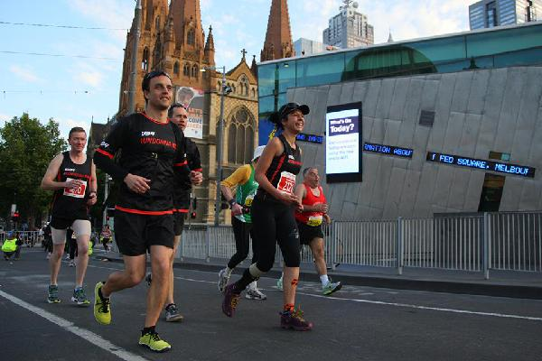

The RDR Team

Marathon Day - October 13, 2013



Get your Tee at the RDR Shop



Get our RDR Shop RockTape discount

You get 20% off Rocktape and Rock Sauce with RDR



Run Donna Run



Get your 30% off Voucher now!

When you donate $20 or more, you receive a 30% of Voucher from www.sub4.com.au